Computer Networks

Network Devices

Student Name: Trần Quốc Anh
Student No.: 1852247

I. Objectives:

- Get to know basic network devices
- Understand functions of network devices
- Able to connect different network devices together to form a simple network

II. Content

1. Get to know network devices:

- Network Interface Card (NIC)
- Cables
- Hub
- Switches
- Routers
- Access Points
- Modems

2. Understanding functions of network devices

a. Network Interface Card (NIC)

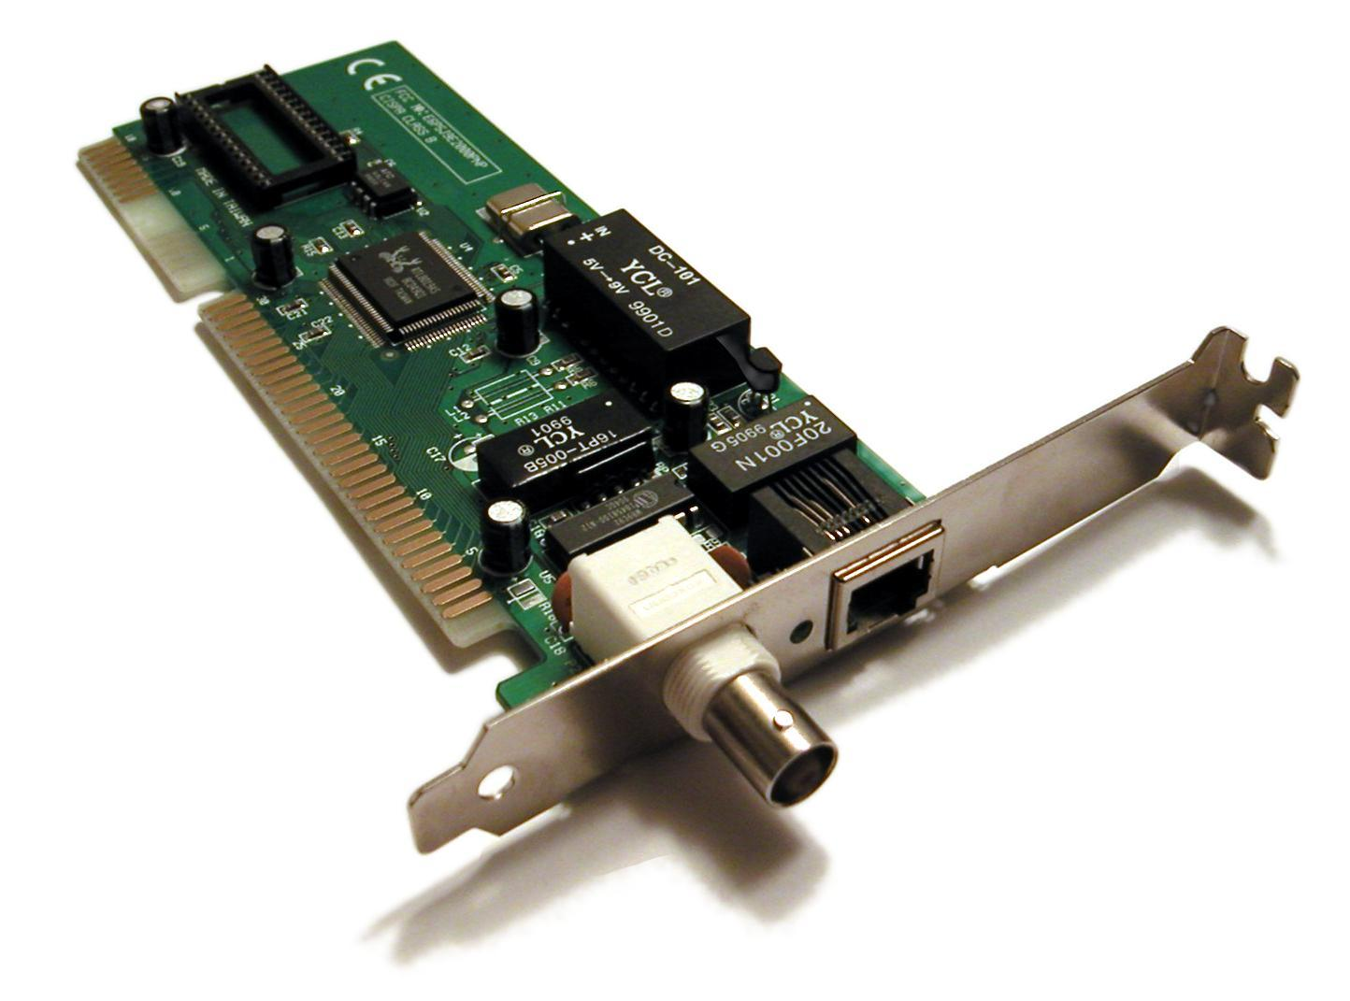
NIC functions: Connects computer to a local data network or the Internet__________
Code of NIC processors: ________________________________________________
Check NIC of a computer, what is its MAC address? 90-32-4B-2D-67-D2
A media access control address (MAC address) is a unique identifier assigned to a network interface controller (NIC) for use as a network address in communications within a network segment.
Cable to connect NIC to a network:
Type: Ethernet, Wireless Network
Standard: IEEE08

b. Hubs

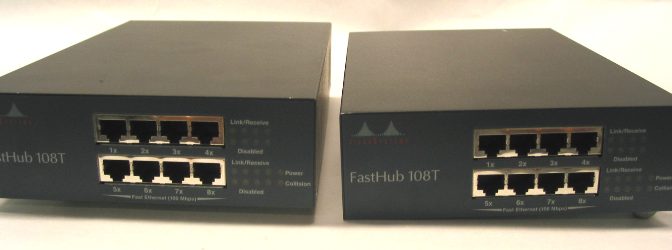

Roles of hub in a network: connects a network of personal computers together, they can be joined through a central hub.
Main characteristics: Data that comes from one port are broadcasted across the network to all ports. A hub operates on the physical layer.
Weaknesses of hub: unables to differentiate between the devices on the network. If one computer is trying to reach another on a hub-based network, the computer will send the message to every other computer on the network, consuming bandwidth for each transfer.
Hub ports: 4/12 ports, RJ45

c. Switches
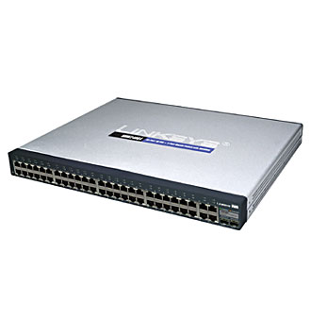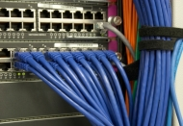
Roles of switches in a network: Allow connections to multiple devices, manage ports, manage VLAN security settingsMain characteristics of switches.
Differences between hubs and switches:
+ Hubs cost lesser than a switch
+ A switch is effectively a higher-performance alternative to a hub
Weaknesses of switches:
+ Network connectivity issues are difficult to be traced through the network switch.
+ Broadcast traffic may be troublesome.
+ If switches are in promiscuous mode, they are vulnerable to security attacks e.g. spoofing IP address or capturing of ethernet frames.
Switch ports: Switch is multi port Bridge. 24/48 ports, RJ45

d. Routers
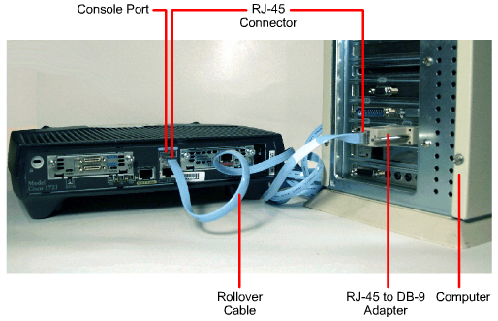

Roles of routers in a network: forwards data packets between computer networks. Routers perform the traffic directing functions on the Internet.
Main characteristics of routers:
+ Routers are multi-port devices with high – speed backbones
+ Routers route traffic by considering the network as a whole using a high level of intelligence.
Differences between routers and switches: a switch is designed to connect computers within a network, while a router is designed to connect multiple networks together.
Router ports:
+ WAN port: WAN stands for Wide Area Network and this is the network that connects router to the service provider.
+ LAN port: LAN stands for Local Area Network and is connected to other computers, switches, and routers using an Ethernet cable.

d. Access Points

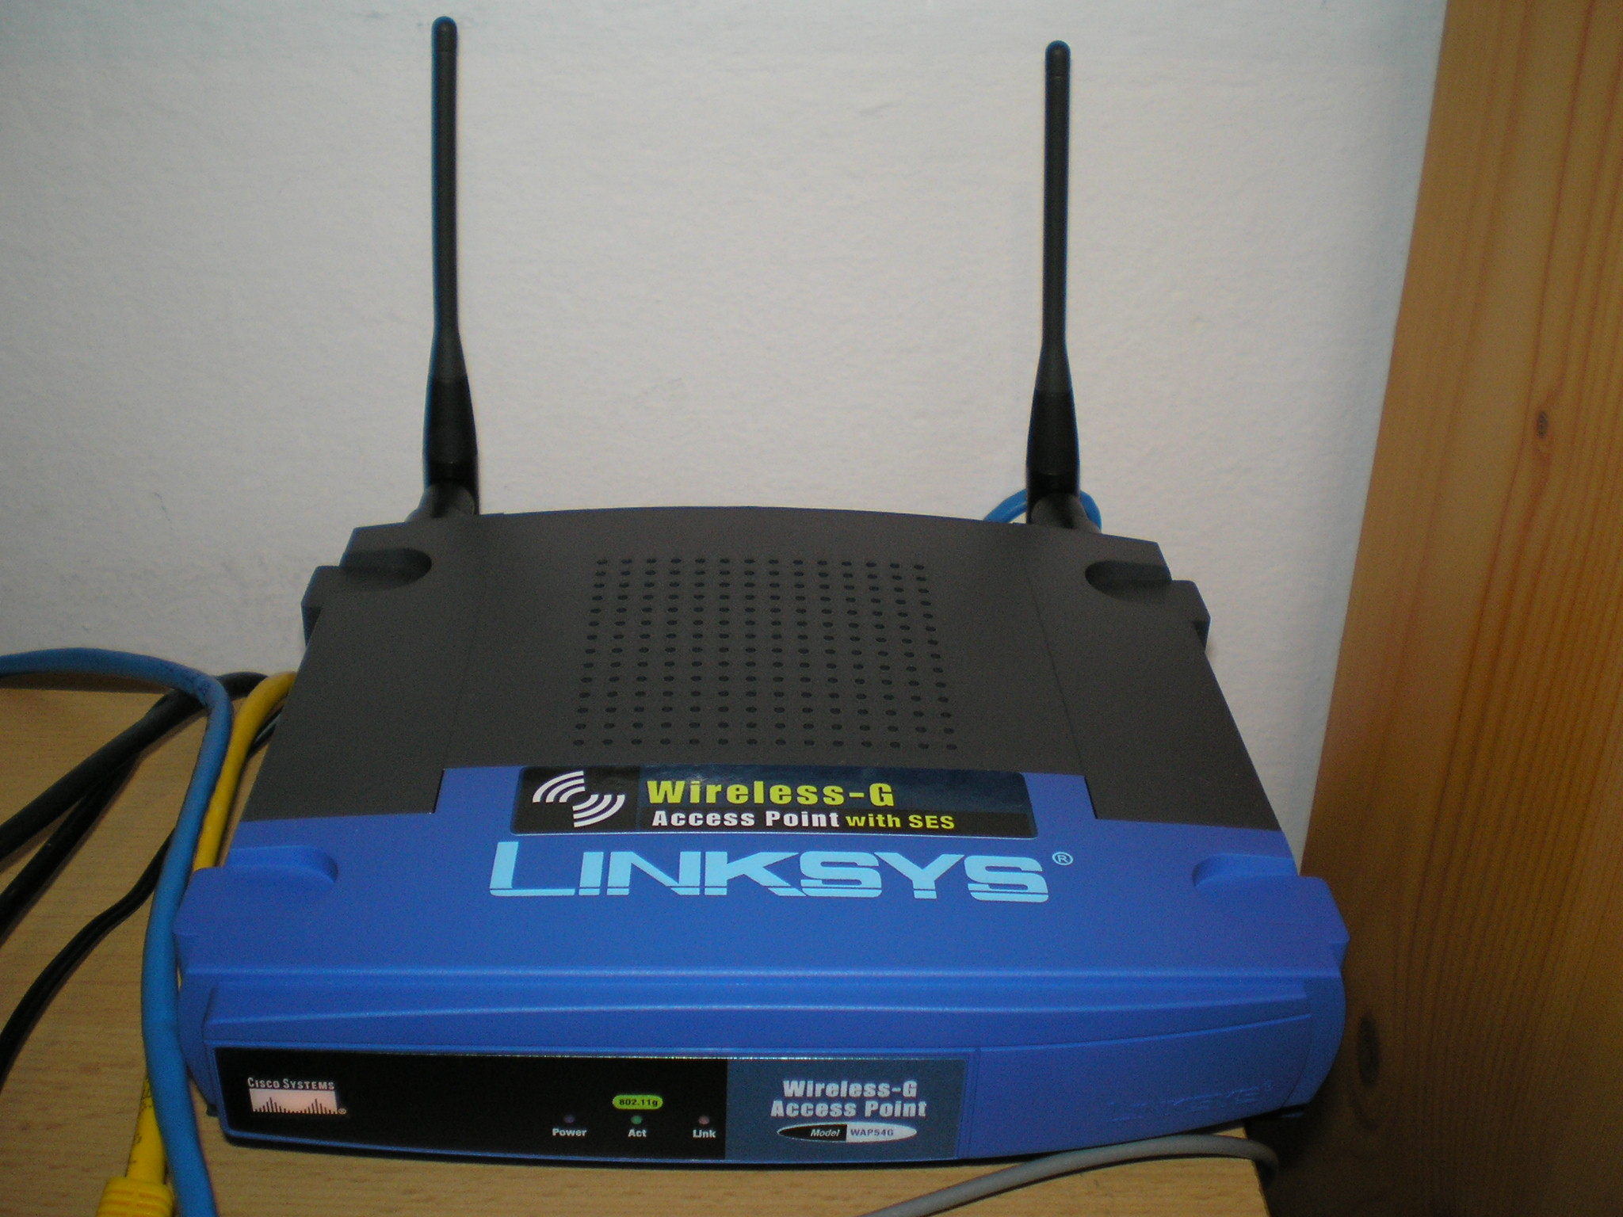
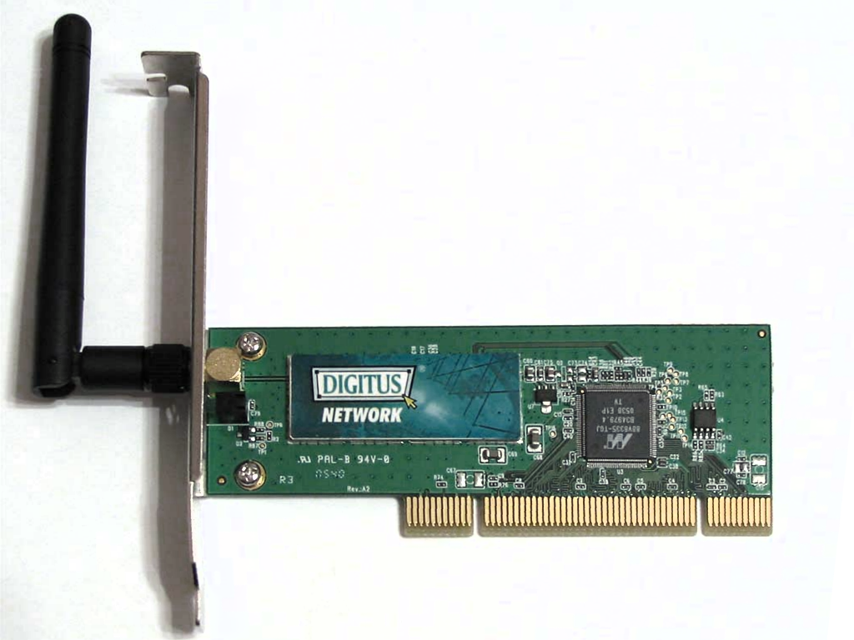

Roles of access points: creates a wireless local area network, or WLAN, usually in an office or large building. An access point connects to a wired router, switch, or hub via an Ethernet cable, and projects a Wi-Fi signal to a designated area.
Main characteristics of access points: can project Wifi signal and handle up to hundreds of device connections at the same time.
Access point’s interfaces:
Compare access point and other networking devices mentioned above:

e. Modem
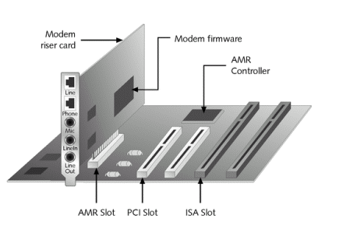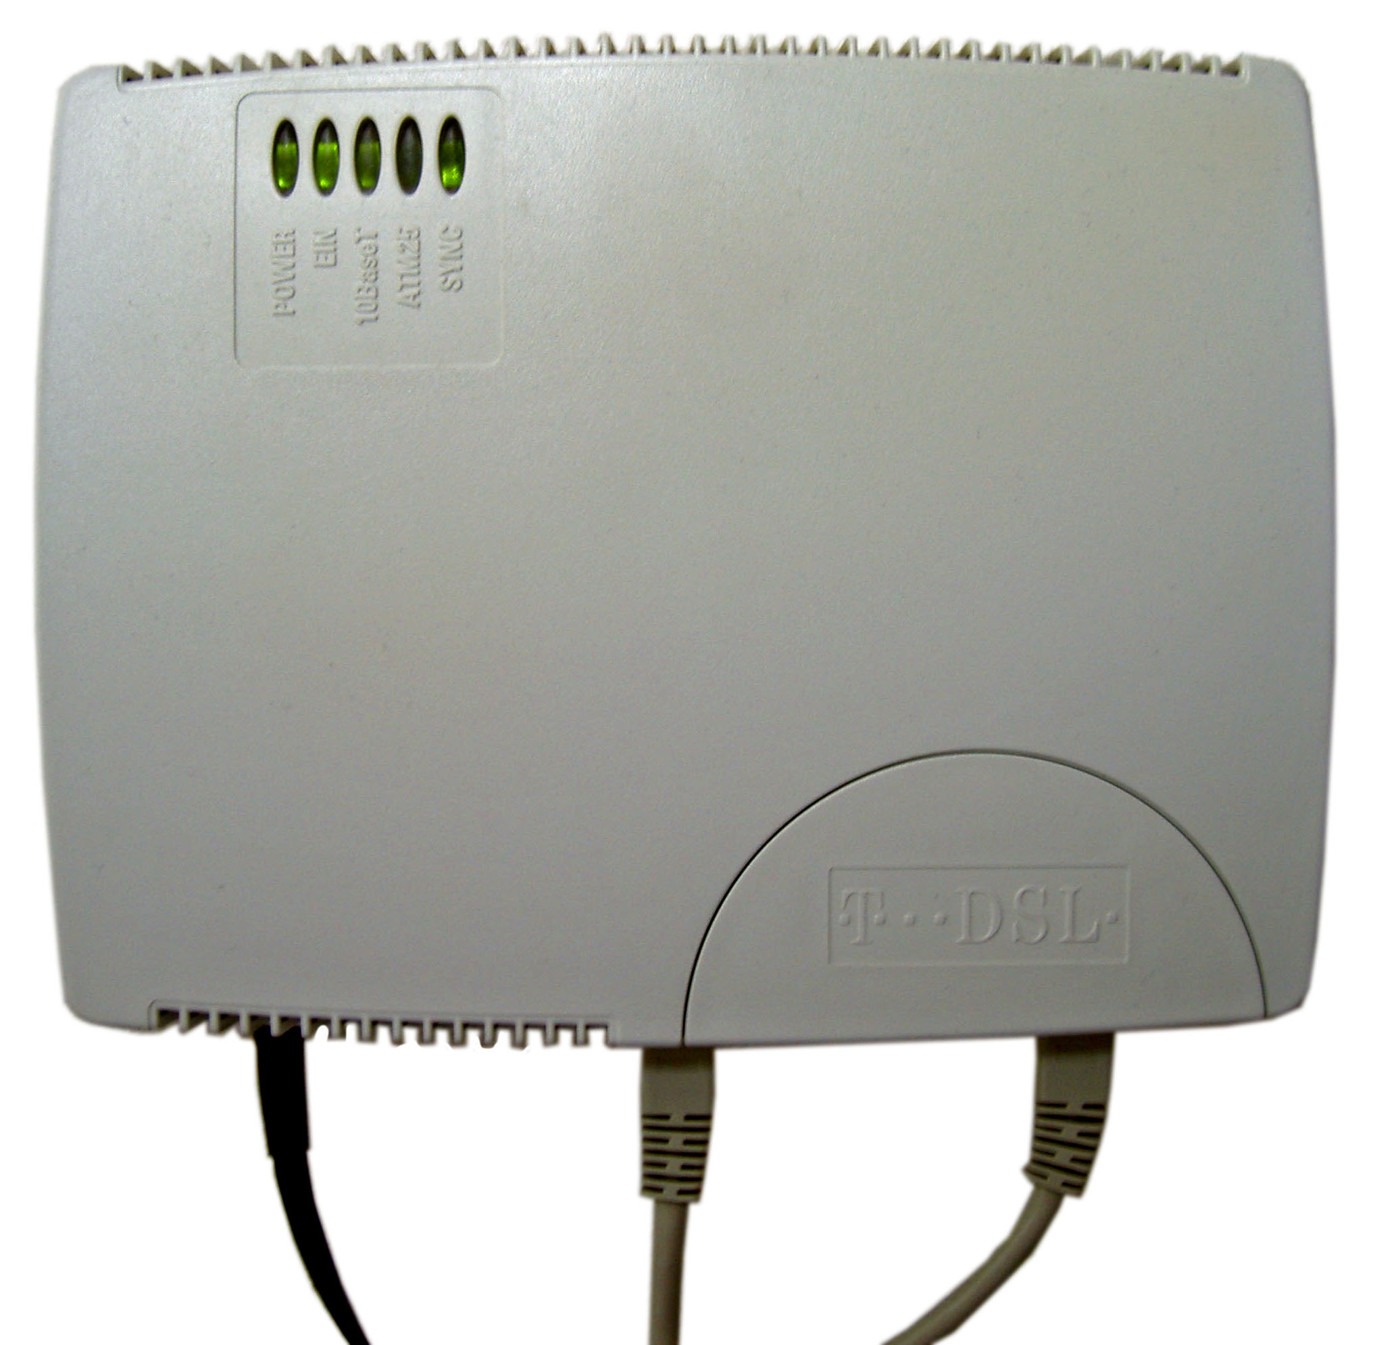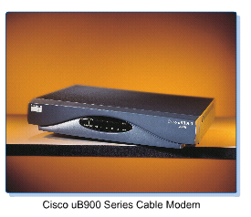

Differentiate:
- Dial-up modem
+ Dial-up modem uses telephone lines to transmit analog signals from the computer to the internet servers and vice versa.
+ This type of connection relies on the use of traditional telephone lines to carry data packets and provide users with access to the web.
- ADSL Modem
+ Asymmetric digital subscriber line (ADSL) is a type of digital subscriber line (DSL) technology, a data communications technology that enables faster data transmission over copper telephone lines than a conventional voiceband modem can provide.
+ ADSL works by using spectrum above the band used by voice telephone calls.[1] With a DSL filter, often called splitter, the frequency bands are isolated, permitting a single telephone line to be used for both ADSL service and telephone calls at the same time.
- Cable Modem
+ A cable modem is a type of network bridge that provides bi-directional data communication via radio frequency channels on a hybrid fibre-coaxial (HFC), radio frequency over glass (RFoG) and coaxial cable infrastructure.
+ Cable modems are primarily used to deliver broadband Internet access in the form of cable Internet, taking advantage of the high bandwidth of a HFC and RFoG network.
3. Connecting network devices:

Identify the type of network cable can be used for below network connections:
a) Computer and hub - Straight-through Cables
b) Computer and switch - Straight-through Cables
c) Computer and router - Straight-through Cables

d) Computer hub and hub - Ethernet Crossover Cables
e) Hub and switch - Ethernet Crossover Cables
f) Hub and router - Straight-through Cables

g) Switch and switch - Ethernet Crossover Cables
h) Swith and router - Straight-through Cables
k) Router and router - Ethernet Crossover Cables

